 | 2, LEBUH ACHEH, GEORGE TOWN  10300 GEORGE TOWN  PULAU PINANG  PENILAIAN AKHIR AMALI
PROGRAM’S CODE & NAME | J620-002-4:2020 FRONT-END SOFTWARE DEVELOPMENT
LEVEL | 4 (FOUR)
COMPETENCY UNIT NO. AND TITLE | J620-002-4:2020-C01: RESPONSIVE WEBSITE DEVELOPMENT
WORK ACTIVITIES NO. AND STATEMENT | - CREATE WEB DESIGN MOCK-UP ELEMENTS.  - PLAN WEB DESIGN STRUCTURE.  - TRANSFORM MOCK-UP TO RESPONSIVE WEB PAGES.  - VERIFY DEVELOPED RESPONSIVE WEBSITE.  - VERIFY WEBSITE ACCESSIBLE GLOBALLY.
CODE NO. | J620-002-4:2020-C01/PA(1/1) | Page: 1 of
NAME
IC NUMBER
DATE
DURATION | 3 hours | MARKS: / 100%
______________
SIGNATURE OF PEGAWAI PENILAI
KERTAS PEPERIKSAAN INI DISAHKAN OLEH JAWATANKUASA KELULUSAN SOALAN

Instruction to candidate:
Write your name and IC number in the space provided.
  - You shall only start reading the questions when you are allowed to do so.
  - Answer all questions.
  - No notes were allowed in the examination hall unless being informed to do so.
  - Cheating is prohibited.
  - You are not allowed to bring this question paper out from this hall.
  - You shall not use the Internet unless you are about to submit your work.
  - Only Bootstrap-related websites are allowed, and they should be accessible locally without the internet.
  - You must complete the task given in the time provided.

THIS PAPER CONSIST OF PRINTED PAGES.

SECTION A:
TITLE: CLONE A WEBSITE

- TASK: You must develop a responsive architecture firm website based on the provided content. The website should be optimized for seamless viewing across various devices and screen sizes. The main structure of the webpage must include four primary sections: ‘Projects’, ‘Services’, ‘Team’, and ‘Contact’.
Note that the Header (Navigation Bar) and Footer are separate components and are not counted as part of these four sections, though they will still be assessed for design consistency and responsiveness.

- INSTRUCTIONS:
  - Download Project Files: Access and download the project files from this link: https://bit.ly/CU1_B19_PA. The files will be in a compressed (zipped) format.
  - Set Up Your Workspace: Unzip the downloaded file and open the project folder using Visual Studio Code (VS Code).
  - Edit the Necessary Files: Focus your modifications on two files:
    - index.html: The main HTML file for your website.
    - styles.css: Located in the /css/ directory, this is the primary stylesheet for your web design.

- DRAWING, DATA AND SCHEDULE:

Figure 1: Navbar expanded 992px and above (Desktop view)

Figure 1.2: Navbar collapsed 768px to 991px(Tablet View)

Figure 1.3: Navbar collapsed 767px and below (Mobile view)


Figure 1.4: Navbar expanded menu 767px and below (Mobile view)


Figure 2: Hero Section (Desktop View)
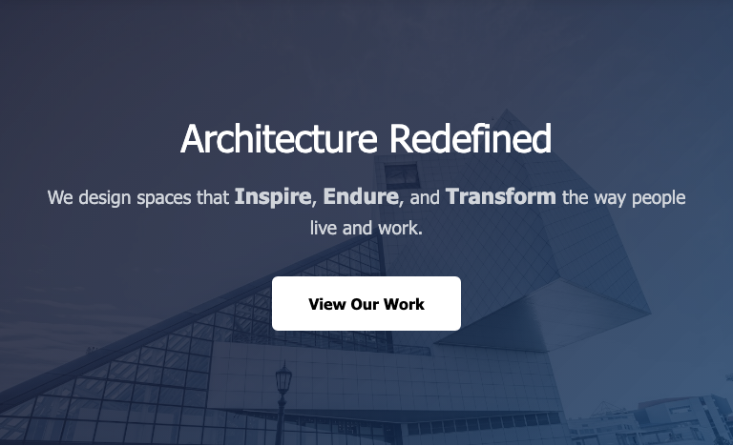

Figure 2.2: Hero Section (Tablet View)
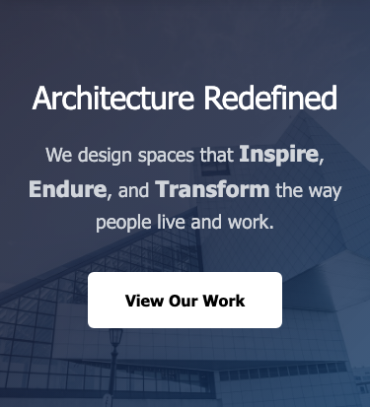2

Figure 2.3: Hero Section (Mobile View)
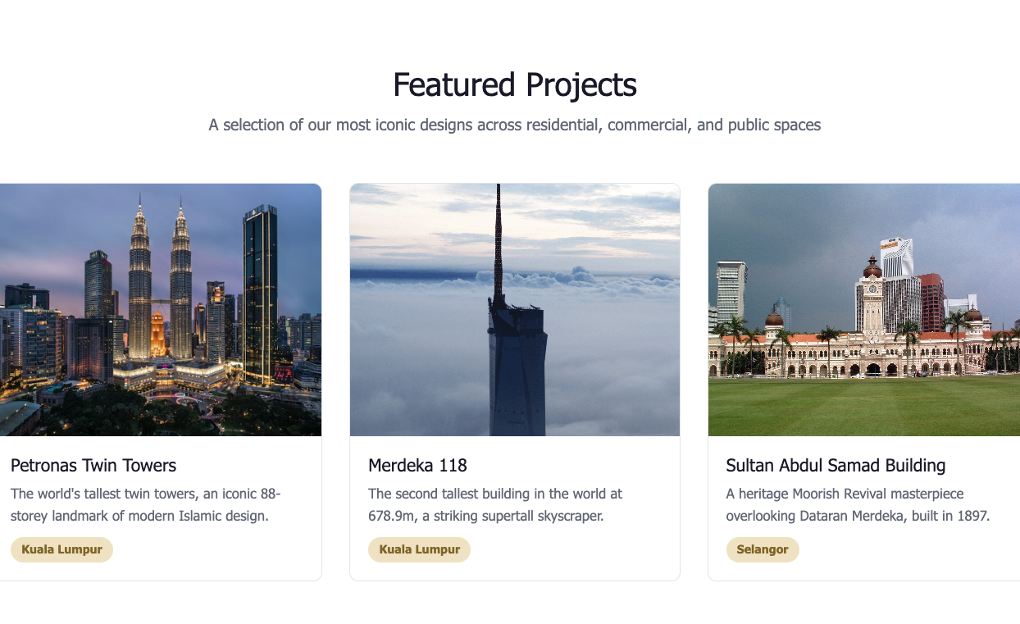
Figure 3: Featured Projects Section (Desktop view)
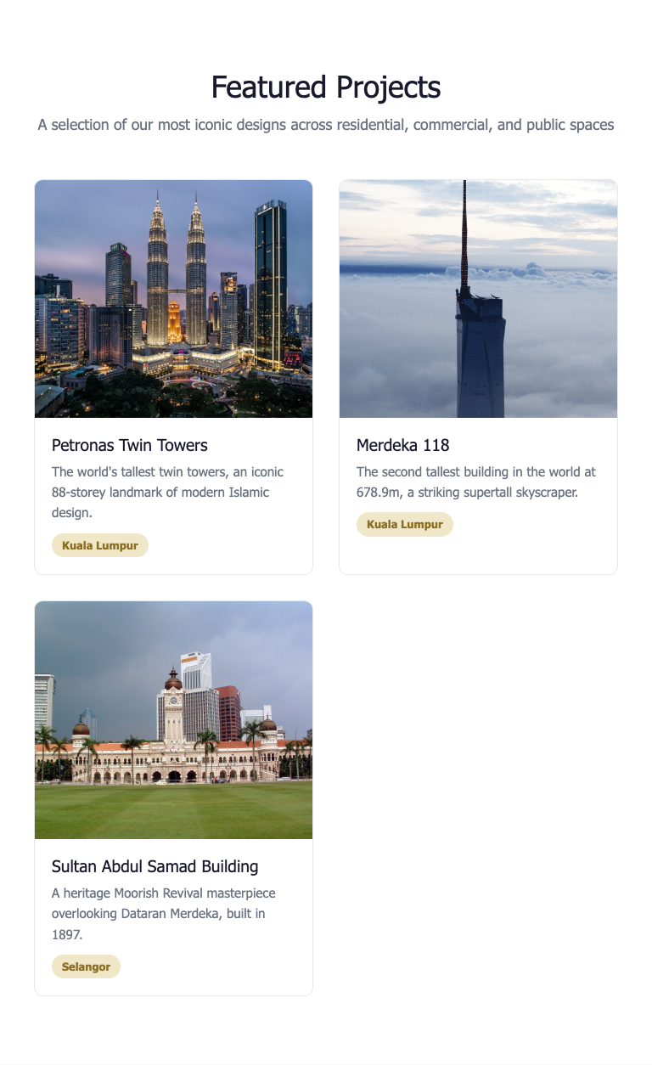

Figure 3.2: Featured Projects Section (Tablet view)
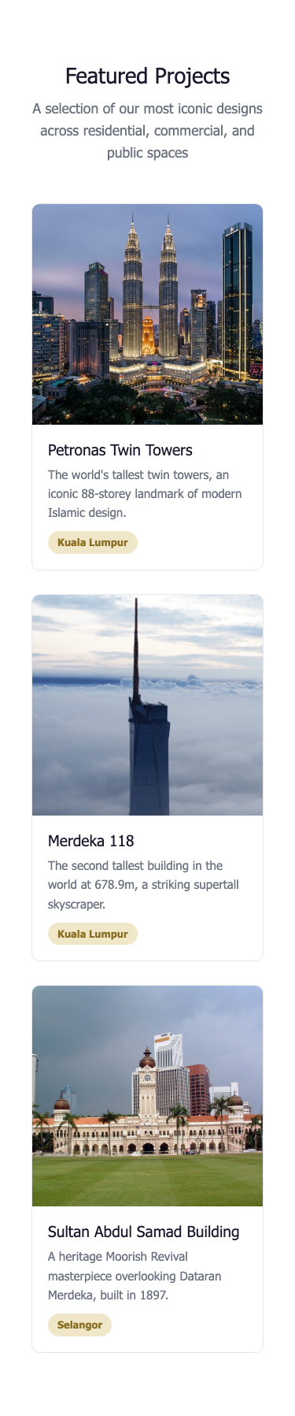
Figure 3.3: Featured Projects Section (Mobile view)

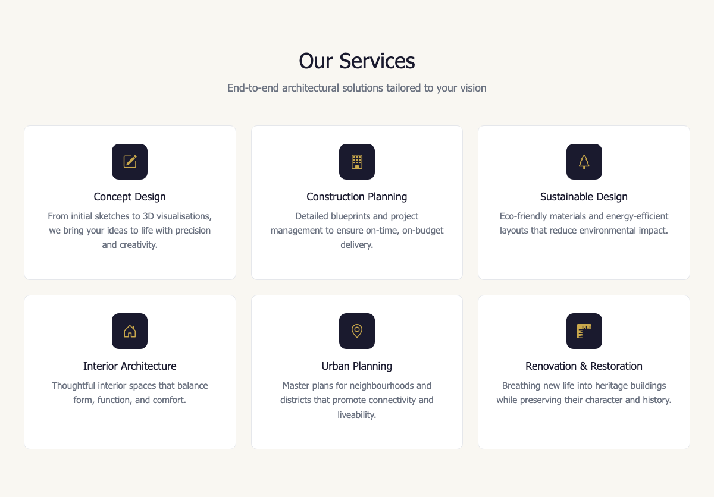
Figure 4: Our Services Section (Desktop view)
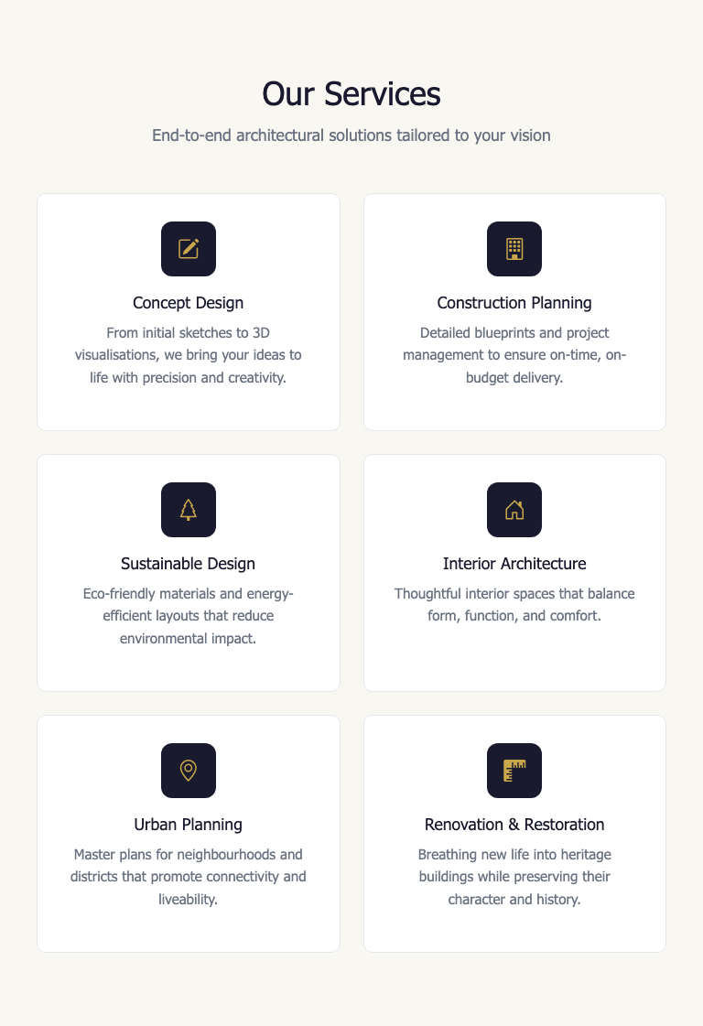
Figure 4.2: Our Services Section (Tablet view)

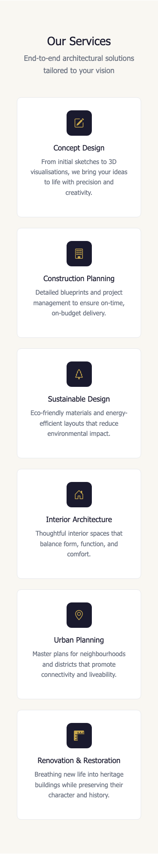

Figure 4.3: Our Services Section (Mobile view)

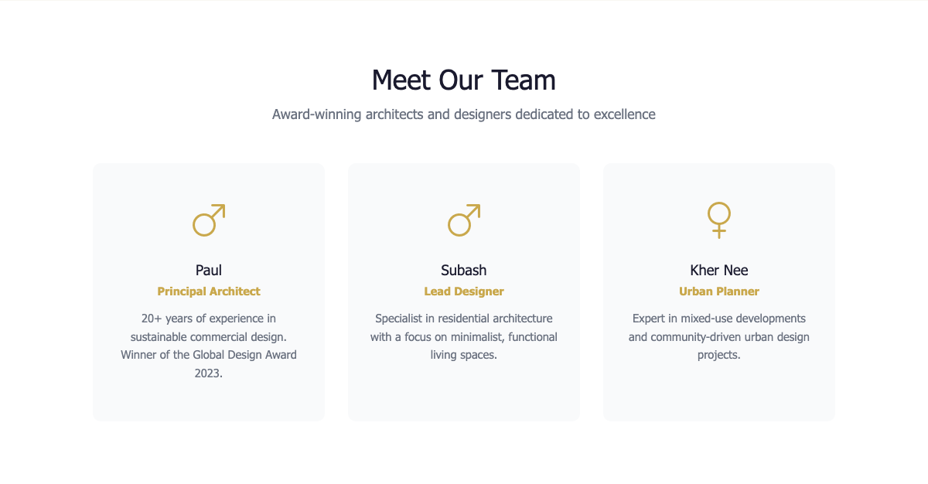

Figure 5: Meet Our Team Section (Desktop view)
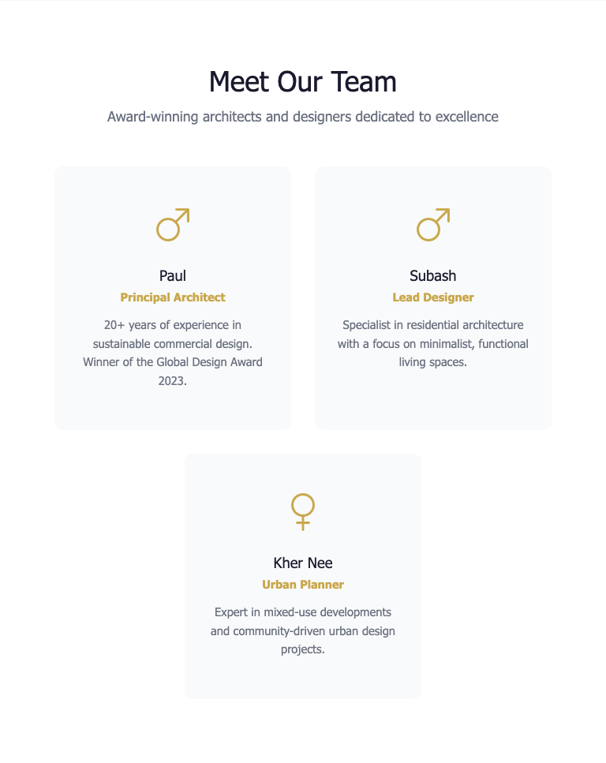

Figure 5.2 Meet Our Team Section (Tablet View)
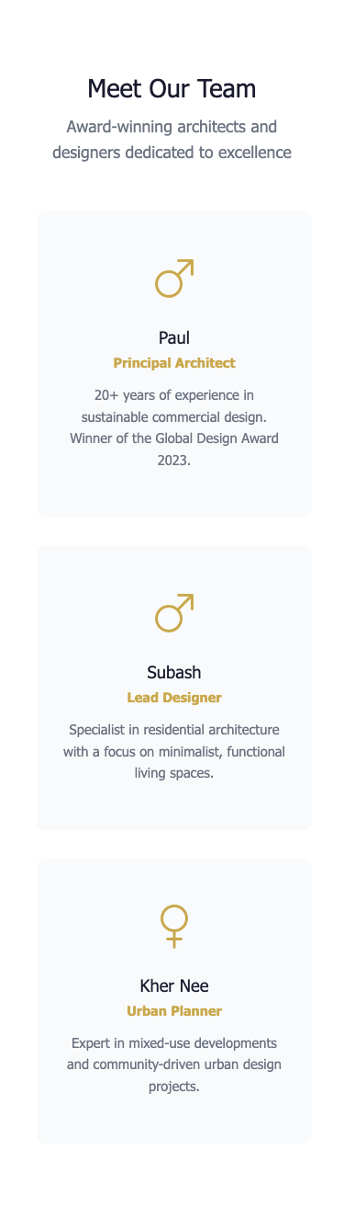
Figure 5.3: Meet Our Team Section (Mobile View)

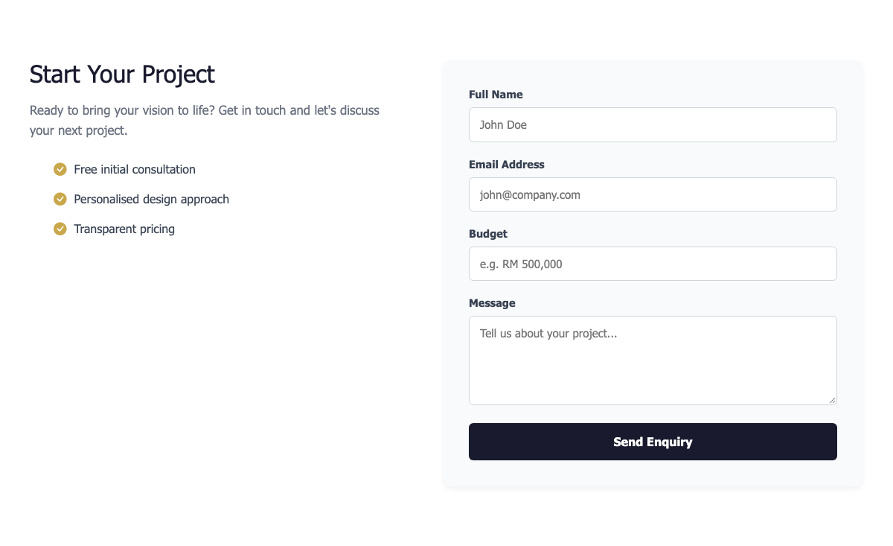
Figure 6: Contact Section (Desktop view)
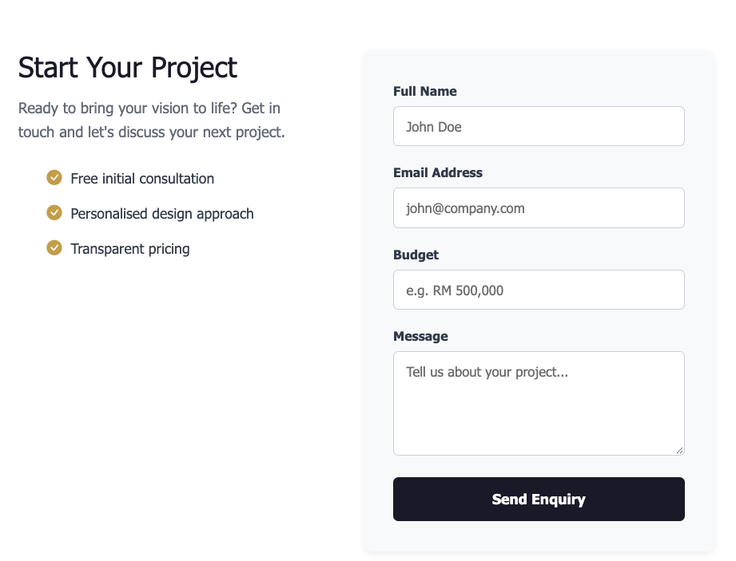
Figure 6.2: Contact Section (Tablet view)

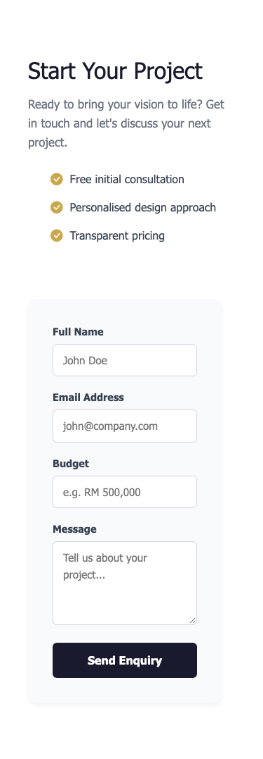
Figure 6.3: Contact Section (Mobile view)


Figure 7: Footer (Desktop view)


Figure 7.2: Footer (Tablet view)

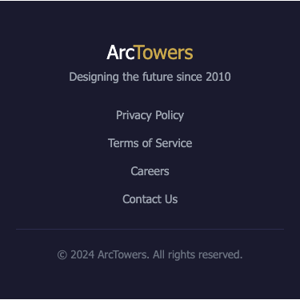
Figure 7.3: Footer (Mobile view)
D. TOOLS, EQUIPMENT DAN MATERIALS
NO. | MATERIALS | QUANTITY  (MATERIALS:CANDIDATE)
- | - | -
NO. | EQUIPMENTS | QUANTITY  (EQUIPMENT:CANDIDATE)
1 | Laptop | 1:1
2 | Table | 1:1
3 | Chair | 1:1
4 | Text Editor (VS Code) | 1:1

E. DURATION: 3 HOURS

F. ASSESSMENT CRITERIA
Candidates’ performance will be assessed according to the following criteria:
- Critical task:
  - Header (Navigation Bar): A full-width, white-background navigation bar with the brand name "ArcTowers" displayed as two-tone text (dark and gold). Navigation links include Projects, Services, Team, and a "Get in Touch" button styled with a white background and black text. All items are centered and responsive. On tablet and mobile screens, the navigation collapses into a hamburger menu icon. (See Figure 1.)

  - Hero Section: This full-width section features a dark gradient overlay on an architectural background image with centered white text. A bold headline reads "Architecture Redefined" followed by a supporting paragraph with bold keywords: "Inspire", "Endure", and "Transform". Below is a call-to-action button labeled "View Our Work" with a white background and black text. The section uses generous padding and demonstrates text hierarchy with responsive font scaling. (See Figure 2.)
  - Featured Projects Section: A white-background section with the heading "Featured Projects" and subtitle. Below is a CSS Grid layout of three project cards featuring real Malaysian architectural landmarks: Petronas Twin Towers (Kuala Lumpur), Merdeka 118 (Kuala Lumpur), and Sultan Abdul Samad Building (Selangor). Each card displays an image, project name, description, and a tag showing the Malaysian state. (See Figure 3.)
  - Services Section: This section displays the heading "Our Services" with subtitles. Below is a CSS Grid layout of six service cards arranged in 3 columns. Each card has a white background, rounded corners, and a subtle border. Each card contains a dark icon box with a gold icon inside, a bold title, and a descriptive paragraph. (See Figure 4.)
  - Meet Our Team Section: This white-background section features the heading "Meet Our Team" with subtitles. Three team cards showing Paul, Subash, and Kher Nee. Each card has a Bootstrap gender icon (male/female), the team member name, role, and description. (See Figure 5.)

  - Contact Section: This white-background section uses the heading "Start Your Project". The left column contains the heading, a descriptive paragraph, and a benefits list with gold checkmark icons. The right column contains a styled form with fields for Full Name, Email Address, Budget, and Message, plus a "Send Enquiry" button. (See Figure 6.)
  - Footer: A full-width footer concludes the page with centered white text. It displays the brand name "ArcTowers", the tagline "Designing the future since 2010," followed by links to "Privacy Policy," "Terms of Service," "Careers," and "Contact Us." At the bottom is the copyright text.(See Figure 7.)

- Task Process: The Task Process assesses how students organize and build the website using proper HTML, CSS, and Bootstrap principles. Students are evaluated on:
  - Project organization: Proper folder structure (css/, img/, js/).
  - HTML/CSS accuracy: Clean, semantic tags and efficient styling.
  - Responsiveness: Correct use of Bootstrap grid and responsive utilities.
  - Consistency: Reusable components (cards, buttons, typography).
  - Sections evaluated include:
    - Header
    - Hero Section
    - Featured Section
    - Services Section
    - Team Section
    - Contact Section
    - Footer
- Task Outcome: The Task Outcome criteria measure how well the final site matches the intended website design and functionality.
  - Visual & Functional Accuracy:
    - The website must include all seven main sections.
    - Layout, spacing, and color schemes must be consistent and visually appealing.
    - Each section should be distinct yet cohesive within the same theme.
  - Responsiveness & Accessibility:
    - The website adapts well to mobile, tablet, and desktop.
    - Text, images, and buttons remain readable and functional across breakpoints.
  - Code Quality:
    - Clean and organized code indentation.
    - Proper naming conventions and semantic HTML5 elements.
    - Use of Bootstrap classes over redundant custom CSS.
  - Design Consistency:
    - Typography, color usage, and spacing should remain uniform across all sections:
    - Font Weight: Consistent hierarchy (headings bold, body regular).
    - Style: Professional and modern.
    - Color: Balanced mix of dark, light, and primary accents.
    - Design: Cohesive aesthetic with visual harmony between sections.
- Attitude/Safety/Environment
  - Submit a project or assignment on time.
  - Attend project or assignment briefing.

Performance Assessment Scheme:
Name of Candidate: |  |  | No. IC:
Start Time: End Time: |  |  | Date:
Marking scale:
0=Underperform/Wrong; 1=Unsatisfactory ; 2=Satisfactory ; 3=Above Expectation

Marking Calculation:
% The weighting will be determined by the expert who developed the question

Section | ASSESSMENT CRITERIA |  |  |  | MARKS
1. | Critical Task (50%) |  |  |  | Mark a (/) on the acceptable and non-acceptable on the following critical task.
1. |  |  |  |  | Acceptable |  | Non-acceptable
1. | 1.1 Header: White navbar with "ArcTowers" logo on the  left and links (Projects, Services, Team, Get  Started) on the right. Collapsible on small screens.
1. | 1.2 Hero: Full-width dark overlay section with heading  "Architecture Redefined", paragraph, and  "View Our Work" button. Centered.
1. | 1.3 Partners: White background with heading, subtitle, and 5 project cards displayed in a row
1. | 1.4 Features: Light background, heading “Powerful Features,” and 6 cards in a grid.Each card has icon,title and description.
1. | 1.5 Pricing: White background with heading and 3  team cards (Paul, Subash, Kher Nee).  Each card has a price, feature list, and button.
1. | 1.6 Contact: two-column layout: left has heading, paragraph, and benefits list; right has contact form (Name, Email, Company, Message).
1. | 1.7 Footer: Footer: Dark footer with "ArcTowers" brand, tagline, links (Privacy Policy, Terms of Service, Contact Us), and copyright text.
1. | (*Critical criteria: 50 marks will be given if the above criteria task was performed. 0 marks will be given if any of the criteria tasks were not carried out.)
1. | Marks obtained (%) |  |  |  | 50
2. | Task Process (30%) |  |  |  | % Weightage |  | MARKS
2. | 2.1 Project Organization
2. | - The project files and directories are well-organized, clearly structured, and easy to navigate |  |  | 3 | 5%
2. | - The project files and directories are mostly organized, but some areas could be improved for better structure. |  |  | 2
2. | - The project files and directories lack organization and structure, making it difficult to navigate and understand. |  |  | 1
2. | - The project files and directories are disorganized and chaotic, hindering any clear understanding of the project structure. |  |  | 0
2. | 2.2 HTML and CSS Implementation
2. | - The student demonstrates excellent proficiency in implementing HTML and CSS code accurately and efficiently, with clean and well-structured code. |  |  | 3 | 15%
2. | - The student shows good proficiency in implementing HTML and CSS code, with few minor errors or areas for improvement. |  |  | 2
2. | - The student's HTML and CSS code implementation has several errors or lacks proper structure, affecting the functionality and aesthetics of the website. |  |  | 1
2. | - The student's HTML and CSS implementation is incomplete or significantly flawed, rendering the website non-functional or visually unappealing |  |  | 0
2. | 2.3 Responsive Design
2. | - The student effectively implements responsive design techniques using Bootstrap and CSS media queries, ensuring the website looks and functions well on various devices and screen sizes. |  |  | 3 | 10%
2. | - The student demonstrates some effort in making the website responsive, but there are areas that could be improved to enhance its adaptability across different devices.. |  |  | 2
2. | - The student's attempt at making the website responsive is limited, resulting in issues or inconsistencies when viewed on different devices or screen sizes. |  |  | 1
2. | - The website lacks responsiveness and does not adapt well to different devices or screen sizes. |  |  | 0
2. | Marks obtained (%)
3. | Task Outcome (15%)
3. | 3.1 Visual Accuracy
3. | - The cloned website visually matches the original closely in terms of layout, colors, fonts, and images. |  |  | 3 | 10%
3. | - The cloned website bears resemblance to the original, but there are some minor variations or inconsistencies in terms of layout, colors, fonts, or images. |  |  | 2
3. | - The cloned website differs noticeably from the original in terms of layout, colors, fonts, or images, impacting the overall visual accuracy. |  |  | 1
3. | - The cloned website bears no resemblance to the original or is visually inconsistent, making it difficult to identify any similarities. |  |  | 0
3. | 3.2 Code Quality
3. | - The HTML, CSS, and Bootstrap code is clean, well-organized, and follows best practices, including proper indentation, comments, and code reusability. |  |  | 3 | 5%
3. | - The HTML, CSS, and Bootstrap code is mostly clean and well-organized, but there are some areas that could be improved in terms of code structure or adherence to best practices. |  |  | 2
3. | - The HTML, CSS, and Bootstrap code is disorganized or contains significant code quality issues, affecting the readability and maintainability of the project. |  |  | 1
3. | - The HTML, CSS, and Bootstrap code is poorly structured, contains numerous errors, or lacks adherence to best practices, making it difficult to understand and maintain. |  |  | 0
3. | Marks obtained (%)
4. | Attitude/ Safety/ Environment (5%)
4. | 4.1 Submit the solution according to the guideline
4. | - The solution is submitted in full accordance with the guidelines, demonstrating exceptional attention to detail and adherence to assessment requirements |  |  | 3 | 3%
4. | - The solution is submitted mostly in accordance with the guidelines, demonstrating satisfactory compliance with assessment requirements and minor deviations |  |  | 2 | 3%
4. | - The solution is submitted with significant deviations from the guidelines, demonstrating an unsatisfactory understanding of the assessment requirements |  |  | 1 | 3%
4. | - The solution is submitted without regard for the guidelines or not submitted at all, demonstrating a lack of understanding or commitment to the assessment requirements |  |  | 0 | 3%
4. | 4.2 Attend the Assessment on Time
4. | - Arrives well ahead of the scheduled assessment time, demonstrating exceptional punctuality and time management skills |  |  | 3 | 2%
4. | - Arrives slightly late (within 10 min) for the scheduled assessment, demonstrating satisfactory punctuality and time management skills. |  |  | 2 | 2%
4. | - Arrives slightly late (more than 15 min) for the scheduled assessment, demonstrating unsatisfactory punctuality and time management skills. |  |  | 1 | 2%
4. | - Arrives significantly late (more than 30min) or does not attend the scheduled assessment, demonstrating a lack of punctuality and time management skills. |  |  | 0 | 2%
4. | Marks obtained (%)
Total Marks Combine
(Section 1 + Section 2 + Section 3 + Section 4)
Assessment Result
MARKS: |  | SHOWN/ NOT SHOWN
FEEDBACK OF PEGAWAI PENILAI
Signature of Pegawai Penilai  Name |  | DATE

